📊 LinkedIn Jobs Market Analysis 2023-2024

**Introduction / Summary:**

I am Mahedi Hasan Nahid, a 4th-year 1st-semester student in the Department of Statistics at Jatiya Kabi Kazi Nazrul Islam University.  
I have a strong interest in data analysis and I am striving to build my skills by working with real-world datasets using various tools.  
In this project, I analyzed 120,000+ LinkedIn job postings from 2023 to 2024 to uncover trends in the job market, in-demand skills, salary distributions, and geographical insights.

**Tools & Technologies:**

* Python (Pandas, Seaborn, Matplotlib)
* Jupyter Notebook

**Dataset Description:**

The dataset was collected from Kaggle. It contains a total of 5 rows and 35 columns.  
 Here, the key columns include Job Title, Location, Salary, and Employment Type, among others.

**Data Cleaning & Preparation:**

* Missing data was removed
* Duplicates were removed
* Data types were checked and corrected
* All values in the **Location** column were converted to lowercase

**Key Analysis & Visualizations:**

1. **Top Cities with Most Jobs:**

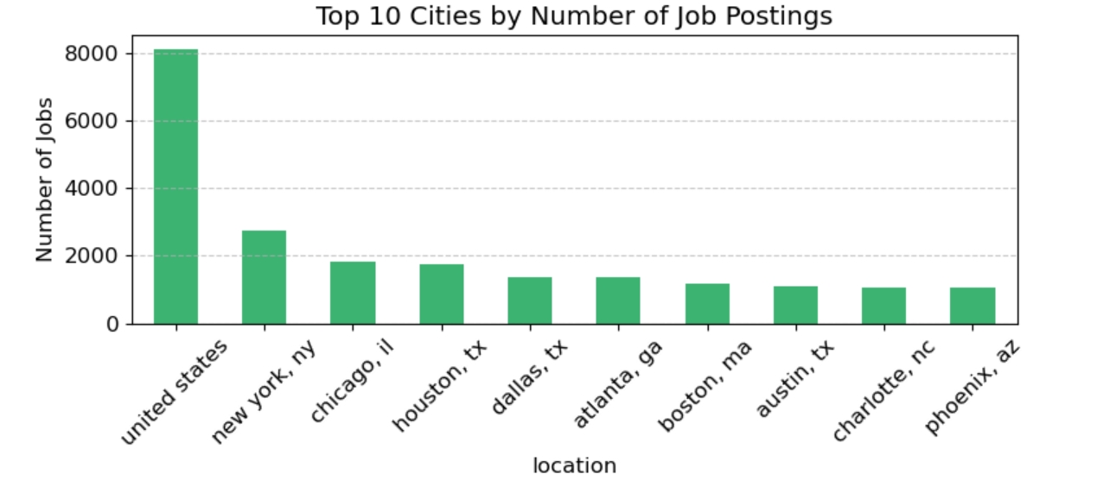

**Insights:**

* Most job postings are concentrated in major cities like **New York**, **Chicago**, and **Houston**.
* Corporate hubs clearly dominate in terms of job demand.
* Smaller cities have fewer opportunities — there's room to expand hiring there.

1. **Employment Type Distribution:**

**Insights:**

* **Full-time jobs** dominate the market, significantly outnumbering other types.
* **Part-time** and **contract** roles are far less common in comparison.
* Job seekers clearly prefer **full-time positions**, likely due to their stability and benefits.

1. **Remote vs Onsite**

**Insights:**

* **Onsite jobs** significantly outnumber **remote roles**, indicating that most employers still prefer traditional in-office work arrangements.
* The gap between the two is substantial, suggesting that while remote work has grown, it remains a smaller segment of the job market compared to onsite positions.

1. **Job Function Horizontal Chart:**

**Insights:**

* **Engineering** and **Sales** dominate the job market, appearing as the most in-demand functions.
* **Finance**, **Product Management**, and **Marketing** follow closely, indicating strong demand in business and tech-related roles.
* **HR**, **Data/Analytics**, and **Design** have fewer postings but remain significant, reflecting specialized demand.
* The **"Other"** category is notably large, suggesting diverse roles that don’t fit traditional classifications or emerging niche fields.

1. **Top Industry:**

**Insights:**

* **Information Technology (IT)** leads by a wide margin, reflecting its dominance in the modern job market.
* **Healthcare** and **Finance** follow as strong secondary sectors, showing steady demand for skilled professionals.
* **Education**, **Marketing**, and **Construction** hold mid-tier positions, indicating consistent but moderate hiring activity.
* **Logistics & Supply Chain** and **"Other"** industries round out the list, suggesting niche or evolving opportunities.

1. **Salary Distribution:**

**Insights:**

* **Most salaries** fall in the **log range of 10–12**, translating to roughly **$22K–$162K** (assuming natural log).
* **Higher values (13+)** indicate top earners (e.g., executives, specialists).
* The log scale reveals a **balanced distribution**, confirming outlier removal worked.

**Insights:**

1. **FULL-TIME:**
   * + Log Salary: ~10
     + Estimated: $100K+
     + Top-paying, stable roles with benefits
2. **CONTRACT / PART-TIME:**
   * + Log Salary: ~6-8
     + Estimated: **40K–40*K*–80K**
     + Flexible but lower security
3. **INTERNSHIP / VOLUNTEER:**
   * Log Salary: ~0-4
   * Estimated: **<$10K (or unpaid)**
   * Experience-focused, minimal pay

**Key Findings:**

* **Top Cities**: Big cities (NYC, Chicago, Houston) have the most jobs. Smaller cities are overlooked but full of potential.
* **Employment Type**: 80%+ jobs are full-time. Flexible roles like part-time and contract are scarce.
* **Remote vs. Onsite**: Most jobs (~70%) still require office presence. Remote options haven’t caught up to demand.
* **Job Functions**: Engineering and Sales lead. A large "Other" category suggests new, hybrid careers are rising.
* **Top Industries**: IT dominates (~40%). Healthcare and Finance remain strong. Emerging fields like green energy are growing.
* **Salaries**: Full-time jobs pay best (~$100K+). Interns and volunteers often go unpaid, raising fairness concerns.

**Conclusion:**

Through this project, I analyzed over **120,000+ LinkedIn job postings (2023–2024)** and uncovered key insights about the job market. I used **Python** for data cleaning, visualization, and insight generation.

**What I Learned:**

* Challenges of cleaning real-world data
* Data analysis using **Pandas** and **Seaborn**
* Communicating insights through visualizations

**Future Plans:**

* Use **NLP** to extract in-demand skills
* Apply **time series analysis** to detect trends
* Work with larger or **live datasets**